**📦 Flipkart Product Review Analyzer Report**

**Prepared By**: Jairam Margam  
**Tool Version**: v1.0  
**Platform**: Streamlit + Python + Gemini API

**🧠 Objective**

To automatically extract and summarize customer sentiments, themes, and actionable insights from Flipkart product reviews — helping businesses improve products, target marketing, and understand user feedback at scale.

**🔗 Product Analyzed**

**Product URL:  
*Go to the Product Page → Click on the Reviews Section → Copy the URL*  
Example:**[**https://www.flipkart.com/mi-20000-mah-33-w-power-bank/product-reviews/itme2dae8e64d942?pid=PWBH3VWYZDWTYBYS**](https://www.flipkart.com/mi-20000-mah-33-w-power-bank/product-reviews/itme2dae8e64d942?pid=PWBH3VWYZDWTYBYS)

**🧪 Methodology Overview**

| **Step** | **Description** |
| --- | --- |
| 🔍 Web Scraping | Reviews scraped using Selenium from multiple pages of a Flipkart product |
| 🧹 Text Preprocessing | Cleaning involved emoji removal, lemmatization, stopword removal |
| 😊 Sentiment Analysis | Used BERT-based model to classify reviews as Positive, Negative, Neutral |
| 🔍 N-gram Extraction | Extracted frequent bigrams and trigrams to identify key phrases |
| 🧠 Topic Modeling (LDA) | Identified hidden themes in positive and negative reviews separately |
| 🤖 Gemini Summary | Gemini API was used to generate concise business-focused summaries |
| 💻 Streamlit Dashboard | Interactive front-end to enter URL, run analysis, and view outputs |

**⚠️ Performance Consideration & Analysis Tips**

* 📈 The app becomes computationally heavy as the number of pages increases, since it scrapes and processes more reviews.
* ✍️ Enabling Grammar Correction triggers Gemini-2.5-Flash, which is accurate but time-consuming as it processes each review individually.
* ⚡ For faster analysis, keep:
  + Grammar Correction OFF
  + Number of Pages between 1–4
* ✅ For more accurate sentiment analysis, especially with spelling/grammar errors corrected, turn Grammar Correction ON.

**📸 Screenshot 1: App Landing Page**

📝 **Description**: The first screen the user sees. Includes the product URL input and configuration options.

📷 *screenshot of Streamlit app homepage*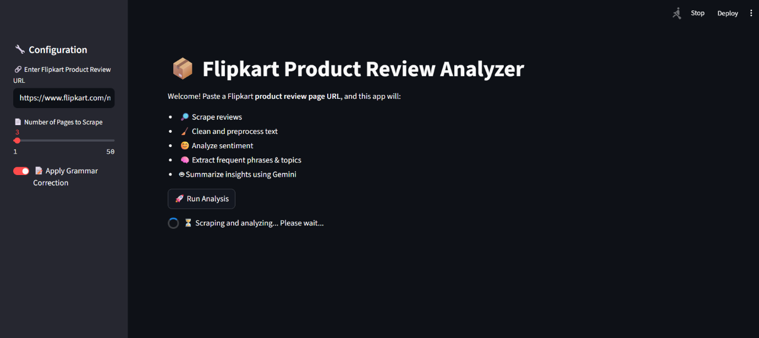

📝 **Description**: Shows a sample of scraped reviews including name, date, rating, title, and description.

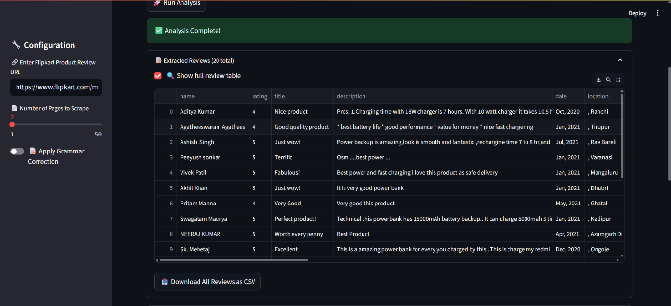📸 Screenshot 2: Sample Raw Reviews

**📊 Sentiment Analysis Summary**

**Sentiment Distribution**:

| **Sentiment** | **Count** |
| --- | --- |
| Positive | 18 |
| Negative | [2] |

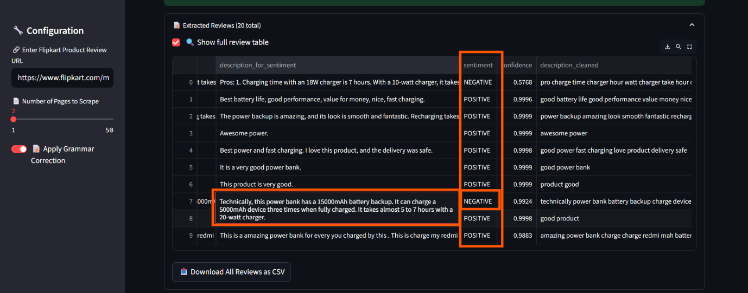📷 *screenshot from “📊 Sentiment Summary” section*

📝 **Description**: Visual/textual breakdown of sentiment results  
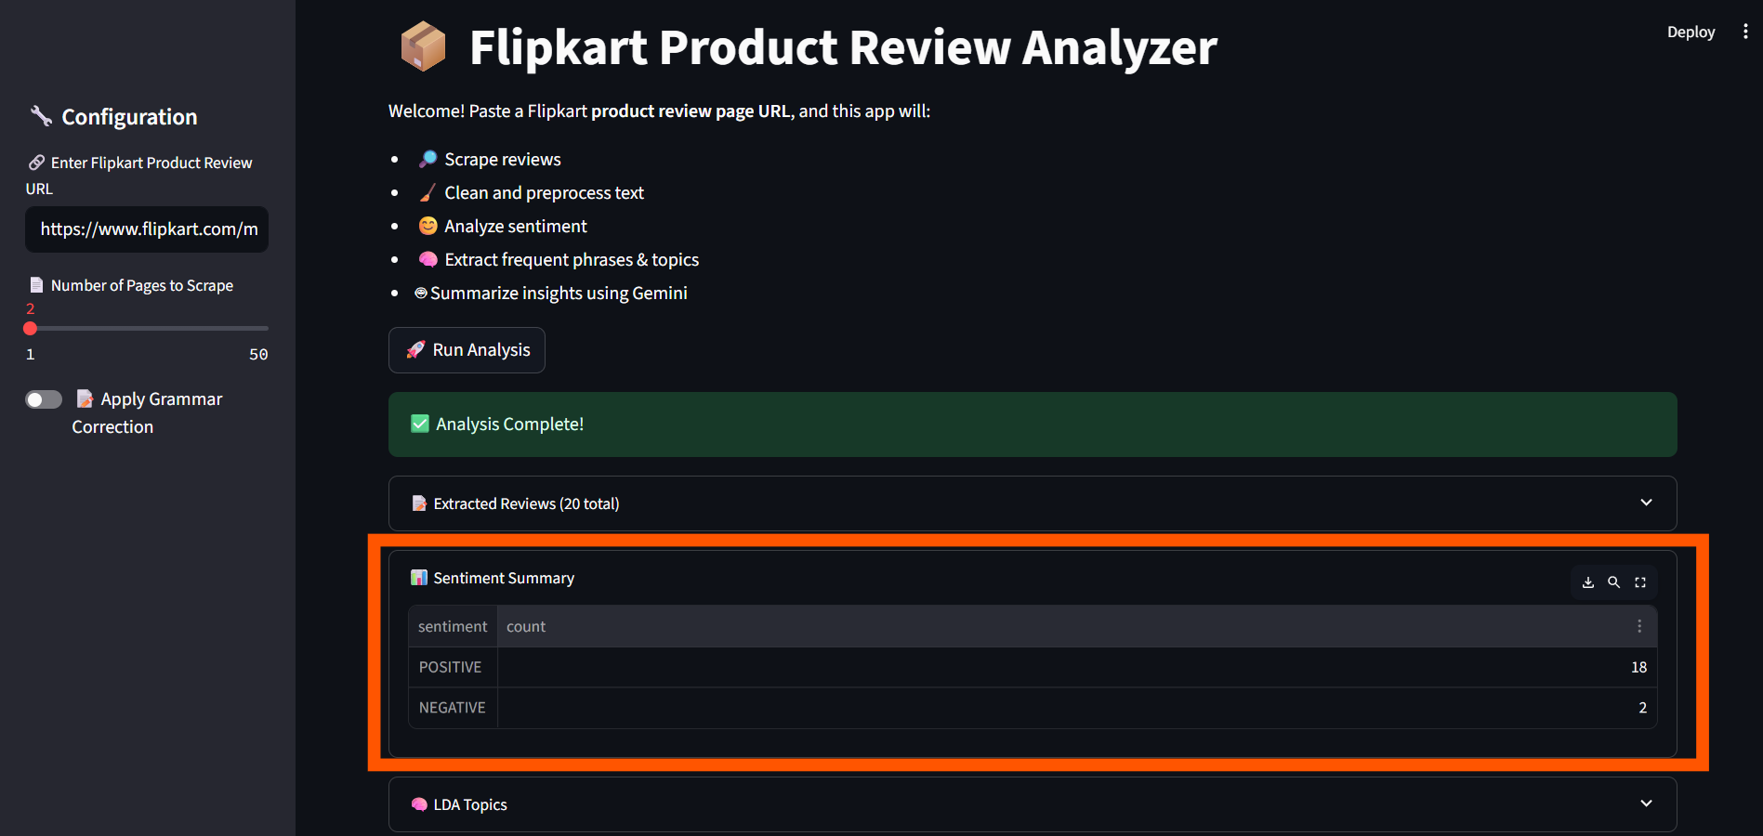

**🧠 LDA Topic Modeling Output**

Topics extracted from:

* **Positive Reviews**
* **Negative Reviews**

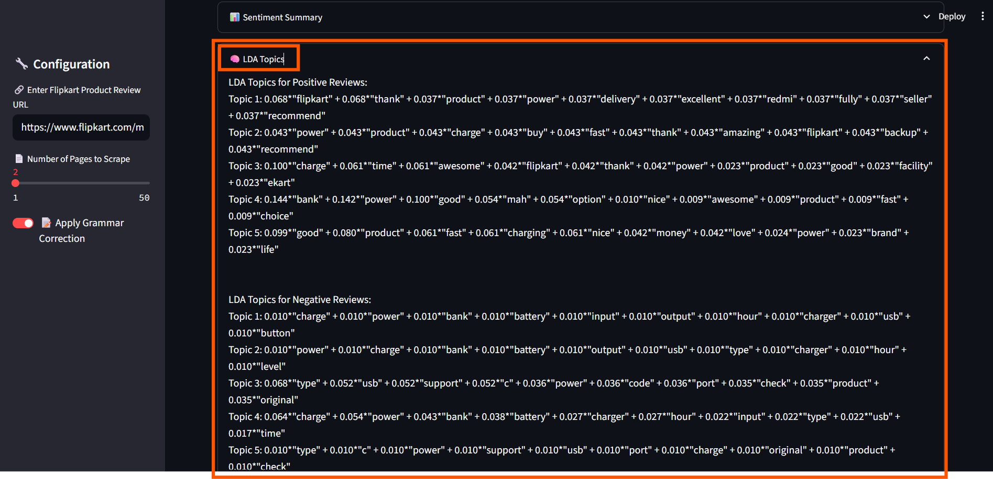 📝 **Description**: Raw LDA topics that capture themes in reviews  
📷 *screenshot from “🧠 LDA Topics” section*

**🔍 Frequent Phrases (N-Grams)**

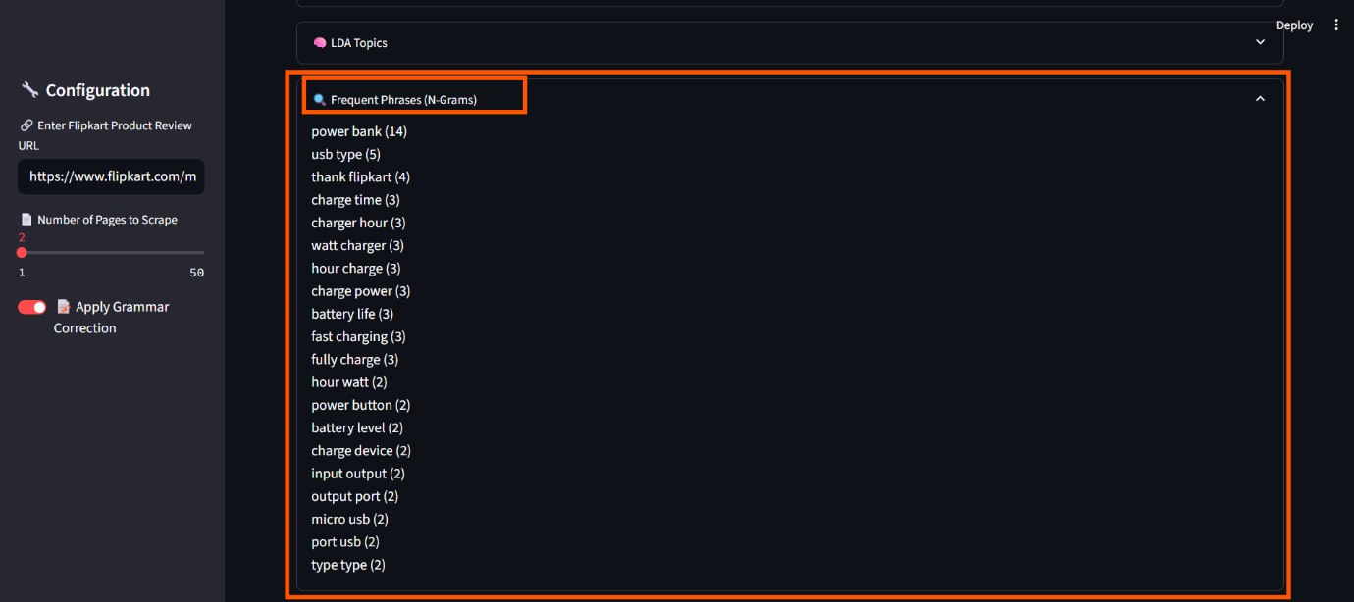These are the most frequently occurring customer phrases (bigrams/trigrams):  
📝 **Description**: List of phrases like “battery life”, “camera quality” etc.  
📷 *screenshot from “🔍 Frequent Phrases” section*

**💬 Gemini Summary – Business Insights**

Here’s a brief, actionable summary generated using Google Gemini AI:

✅ **What customers like**:

* [Fast charging and good battery backup.

Good value for money and overall product quality.

Reliable and fast delivery service (Flipkart).]

❌ **What customers dislike**:

* [Long charging time for the power bank itself.

Issues with USB Type-C port compatibility and support.

Concerns about battery performance and input/output port reliability.]

🔧 **Recommendations (What need to improve)**:

* [**What the Business Should Improve:**

Optimize the power bank's own charging time.

Ensure full and clear compatibility/support for USB Type-C ports.

Address and resolve issues related to overall battery performance and port durability.]

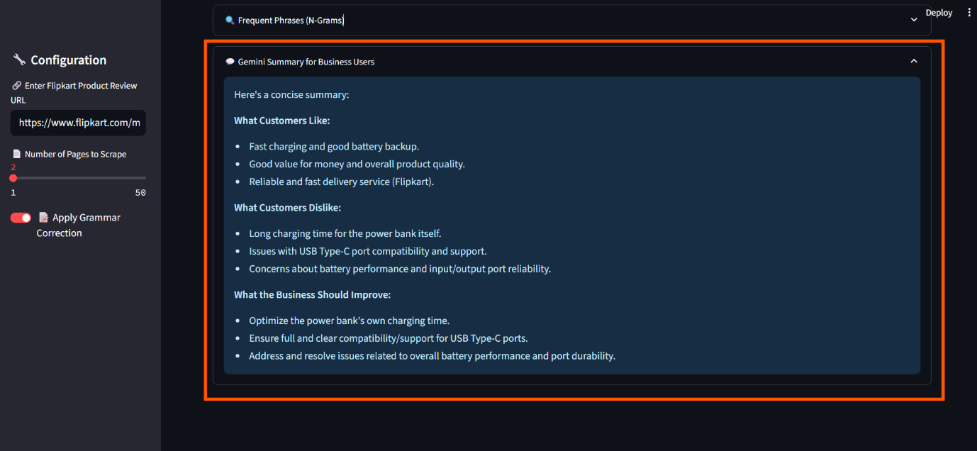  
📝 **Description**: The final business-friendly summary generated using AI  
📷 *screenshot from “💬 Gemini Summary” section*

**📌 Key Business Takeaways**

* Gain instant visibility into product issues or praise without manual review reading.
* Identify emerging patterns or complaints early through topic modeling.
* Equip product and marketing teams with actionable insights.

**🔧 Future Enhancements**

* 📈 Add sentiment-over-time tracking
* 🆚 Compare multiple products/brands
* 📤 Automate email report delivery
* ☁️ Add word clouds for better visual understanding

**🔚 Conclusion**

This tool empowers Flipkart and product vendors to understand the **voice of the customer at scale**, transforming unstructured reviews into **clear, actionable intelligence** using cutting-edge NLP and Generative AI.